Experiment-10

Triggers

1. Create a table with attribute sname and another table with newname

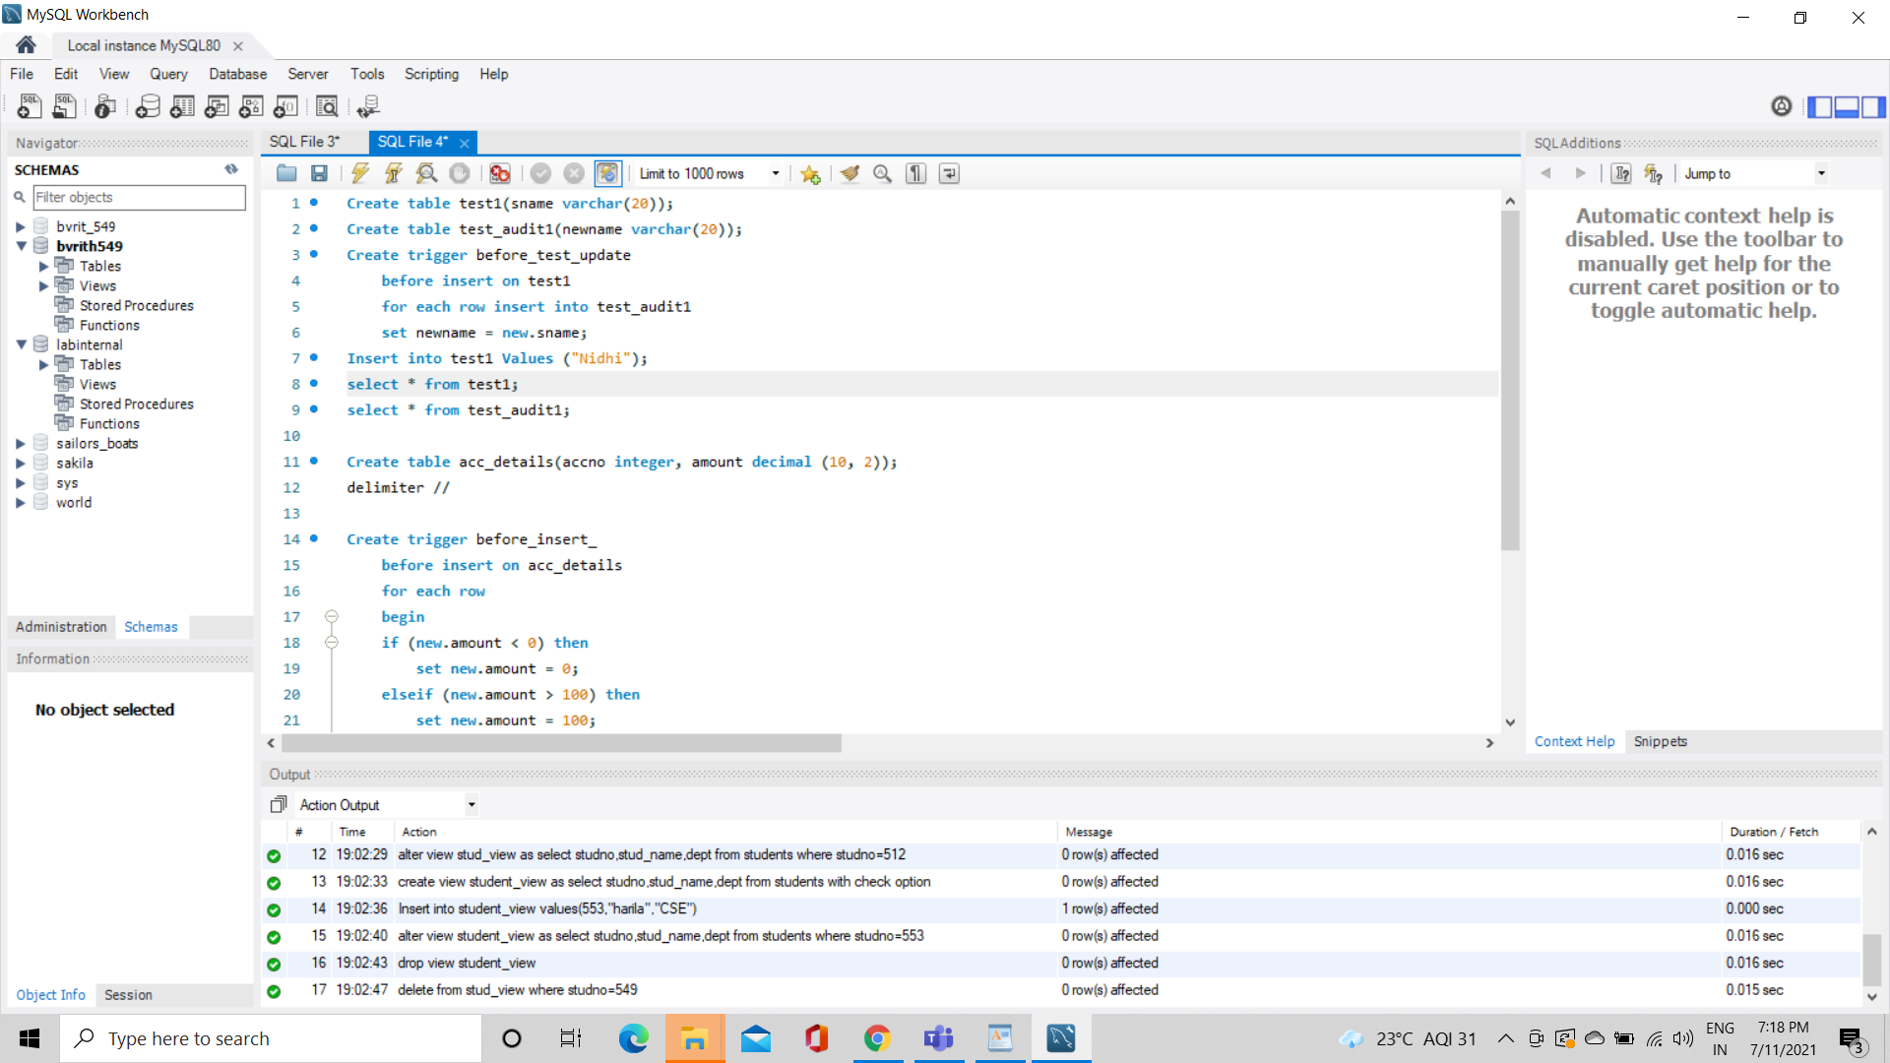

2. Create a trigger to insert second table before inserting the first table

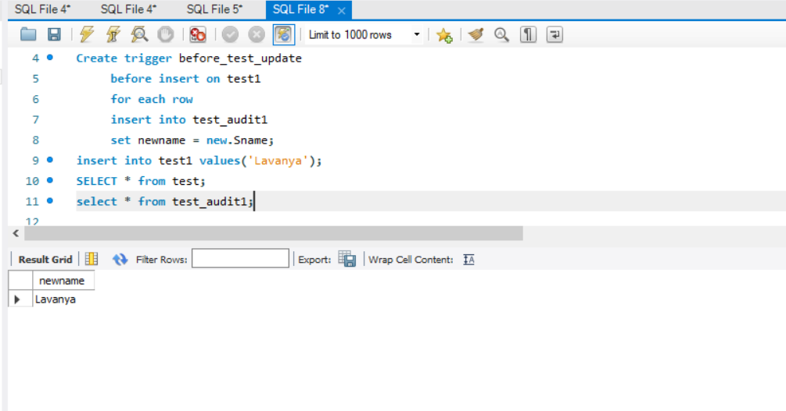

3. Create a table for account details with attributes account number and an amount.



4. Create a trigger to check if amount is negative or greater than zero before inserting to table.

